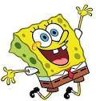
Narrative Celebrations

When giving positive comments to your peers…
BE SPECIFIC!!!
- Word choice—Which words or phrases were the most powerful? Why did you like these words/phrases?
- Plot event—Which specific event did you enjoy the most? Why?
- Character—Which character did you enjoy the most? Why?
- Theme—What theme did you learn and why did you like the theme?
- Character—Which character do you relate to the most? Why?
- Grammar—Are you impressed with their understanding of commas, semi-colons, periods, and capitalization? Why?

