Class Contract and Mission Statement: 6th Grade

We agree on the following expectations, in order to maintain a respectful classroom community:

- We will accept others’ differences by choosing to be kind, patient, and by trying to compromise when there are disagreements.
- We will be courteous of the classroom property, materials, teacher, and classmates.
- We will listen while others are speaking by looking at the speaker, by not talking to others, and by showing positive body language (hands on desk or to the side, not playing with anything).
- We will not bully one another (verbal, physical, emotional, cyber bullying) and will include everyone.
- We will encourage and care for our peers and work together as a team.
- Above all, we will follow the Golden Rule: treat others how you want to be treated.
- We will try to have growth mindsets when participating in all activities and completing assignments; this means we will be reflective and challenge ourselves in order to learn more.

As a 6th grade, it is our mission for the 2014-15 school year to:

- Work hard and try our best when learning in all subject areas
- Be responsible and mature
- Be ourselves and have fun
- Keep an open mind
- Help each other grow by being friends and respectful to one another
- Clean up after ourselves
- Read 500 books total as a whole class

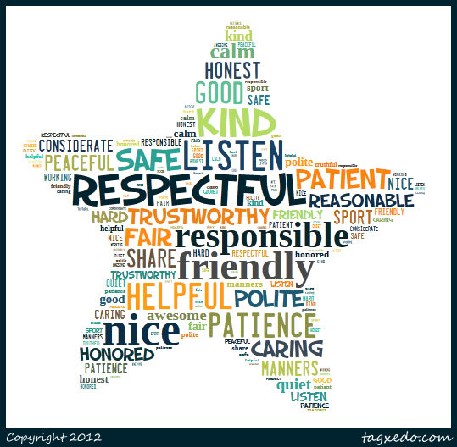
By signing this, I agree to adhere to these expectations and strive to make our classroom a productive, positive, and safe community of learners. If I cannot do this, I understand that the consequences set forth on the first day of school will be enforced, and I will have a conversation with Miss Chamoun/Mr. Weir about how I can contribute to our classroom community in a more positive way.
Student Name (Printed): ___________________________________________

Student signature: _________________________________________________

Parent signature: __________________________________________________

