**What was appealing about Egypt and Kush?**

* They both settled near the Mediterranean Sea.
* Egyptians lived near the southern part and the Kushites lived near the northern part.

**Why settle near body of water?**

* The Mediterranean Sea created a fertile valley that ended in a marshy delta where it emptied into the Nile River.
* Since it was bordered by the Barbarian Desert and the Shoeman Desert with hot and dry temperatures, most people avoided these areas.
* Many people tried to invade the deserts.

**What did the early settlers eat?**

* The Nile River was rich in seafood.
* The Mediterranean Sea provided natural irrigation and fertilization that made the soil great for farming.
* The Sea Valley provided a lot of wildlife, plants, and wheat and barley even though the surrounding deserts were dry.

**How did Egyptians classify their people?**

* Egyptians belonged to a social pyramid where everyone belonged to a specific status in society.
* The peasants were at the top of the pyramid.

1. Peasants
2. Pharaohs
3. Priests
4. Government Officials
5. Scribes
6. Artisans

**Ancient Egypt Settlement**

*Source: Yahoo Answers*

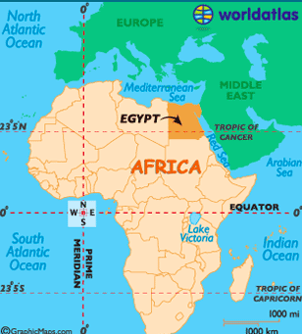

**What was it like to belong to a social class of people?**

* Artisans like carpenters, metal workers, and painters were very skilled but were the lowest of the pyramid, which is where the term “Starving Artist” came from.
* Peasants were the smallest social class, although they provided much of the food supply to the Egyptians.
* Scribes carried out orders from the Priests.
* Government Officials, although high on the pyramid, were not the wealthiest of people.

**What was life like in Egypt?**

* Settlers were able to move from one class to the other easily.
* Belonging in Egypt meant valuing family life.
* Women were the heads of the household, while men stayed home to train the children.
* Women had the freedom, unlike many other civilizations.

**What was it like to be a government official?**

**What was it like to be a priest?**

**What was it like to be a scribe?**

**What was it like to be an artist?**

**What was it like to be a peasant?**

**Words to know!**

1. Mediterranean Sea
2. Nile River
3. Egypt
4. Kush
5. Social Pyramid
6. Social Class
7. Status
8. Noble
9. Peasant

**Settling and Belonging Brochures/Books**

Oh no! The Field Museum is looking to use this brochure/book to guide visitors through their current Egyptian exhibit.

So what is the problem? The book is FILLED with incorrect facts! Their employee used Yahoo Answers to write this brochure.

So what is your job? Your job is to help them revise this brochure to make sure their visitors are getting accurate information!

So how do you complete this? Following these steps…

* **Step 1**🡪 Read through sections 7.3 & ALL of chapter 9
* **Step 2**🡪 Take notes using the SQR3 model we practiced in class
* **Step 3**🡪 Show Miss C your notes for approval
* **Step 4**🡪 Start revising and correcting this brochure
* **Step 5**🡪 Decorate the brochure to make it appealing to the eye (if you need to, add artwork, photos WITH source information, etc.) ☺
* **Step 6**🡪 Turn it into Miss C and be prepared to present!

How will you be assessed? You will be assessed using a checklist that we discussed at the start of the year. This will help to ensure you are using the appropriate information and learning the content.