Creating and Organizing the Classroom Library

Goal: (1) To identify, describe, and explain the various genres/topics/series in literature
(2) To organize a classroom library system

Your Job: (1) List genres/topics/series in literature
(2) Write an explanation of the genre/topics/series
(3) Create a symbol for the genre/topics/series
(4) Identify books that are in the classroom library that fit that genre/topics/series
(5) List the books in your explanation of the genre/topics/series
(6) Organize those books into the designated genre/topics/series bins
(7) Place genre/topics/series bin on a designated classroom library shelf

Example:
**The following example would be handwritten or typed on ONE sheet of paper, and then attached to the front of the book bin.

Realistic Fiction
This genre is about realistic people and themes. The authors of this genre create characters and themes that readers find engaging but relatable. For instance, some themes could be about friendship, love, and family.

Some examples novels in this genre include:
Stargirl
Holes
Walk Two Moons

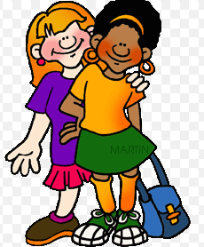

Steps: (1) List genres/topics/series in literature as a whole class
(2) Get into groups
(3) Select genres/topics/series to work on
(4) DRAFT the example above
(5) Start organizing books into bins and create final bin cover
(6) Place post-it notes into inside cover of the novel with the title of the genre/topics/series

